

Warnings and prompts test plan

Propulsion system simulation

Fangzhou chen Jiacong li Marco Hoogesteger Martijn Crombeen

*Organisation: Solar Boat Sealander*

*Client: Mr. R. Eijlers*

*Tutor: Mr. W. Haak*

*Date: 3-11-2020*

2020

Table of content

1. Aim & Hypothesis 2

1.1. Aim 2

1.2. Hypothesis 2

2. Variables 2

2.1. Inputs 2

2.2. Outputs 2

3. Tools 3

4. Method 3

4.1 Data collection 3

4.2 Calculate current & efficiency 3

4.3 Calculate torque 3

4.4 Calculate output power 3

4.5 Calculate rotation speed 3

5.Expect result 4

# Aim & Hypothesis

## Aim

Verify the warnings and prompts component can clearly inform users the state of the simulation.

## Hypothesis

Warnings and prompts appear on the right time when simulations are failed or successful.

# Variables

These are the constants and variables that will be used during the test.

|  |  |
| --- | --- |
| Constants simulation | Keep constant at... |
| Battery level computer | Constant power source. |
| All input variables | Real positive numbers & ISO-notation. |

## Inputs

The limits stated are the limits of the real world. If values out of this range are entered, the outputs will be unreliable.

|  |  |
| --- | --- |
| Inputs | Value |
| Input value [U] | Random numbers, letters, and signals |
| Simulation input state signal | True or False |
| Simulation state signal |

## Outputs

These are the outputs that will be monitored and will be used to see variations or changes in the system.

|  |  |
| --- | --- |
| Outputs | Value |
|  |  |
| Prompts for successful simulation | Successful simulation |
| Warnings for unsuccessful simulation | Simulation failed |
| Prompts for how to optimize unsuccessful simulation | Input error. Please insert numeric values. |

# Tools

|  |  |
| --- | --- |
| Testing tools | Demand |
| Computer | Windows 10 compatible |
| Excel | Newest version |
| Keyboard | No limit |
| Mouse | No limit |
| Calculator | Basic calculator |
| Pen & Paper | Basic pen & paper |

# Method

This section consists of actions that need to be performed during the test to conclude a result. The conditions of the constants stated in chapter “2. Variables” have to be met before executing the simulation. To execute the simulation, follow the steps stated in “4.1. Steps”.

In this test, a simulation in Excel with the same structure as the following graph is needed.



Fig 1 Warnings and prompts test simulation example

**Input value [U]** is the value we need to change. **Coefficient [I]** is a constant which will be set before test. **Output value [P]** is equal to ‘**input value** * **coefficient [I]**’. The **simulation input state signal** shows the state of **input value [U]**. If **input value [U]** is a numeric number, **simulation input state signal** is True, otherwise it will be False. The **simulation state signal** shows the state of **output value [P]**. If **output value [p]** is a numeric number, **simulation state signal** is True, otherwise it will be False.

## 4.1 Steps

1. Create a new form in Excel.
2. Take the grid A2 as the input block of **Input value [U]**. Take the grid B2 as the indicator of **simulation input state signal.**
3. Take the grid C2 as the indicator of **coefficient [I]**. Take the grid E2 as the indicator of **output value [p]**. Take the grid F2 as the indicator of **simulation state signal**. And add a formula to E3: = A2 * C2.
4. Add the function ‘Isnumber()’ to grid B2 and monitor the value of A2. Add the function ‘Isnumber()’ to grid F2 and monitor the value of e2.
5. Input all the codes in following graph in ‘Developer >> Visual Basic >> Sheet1 (Sheet1)’.

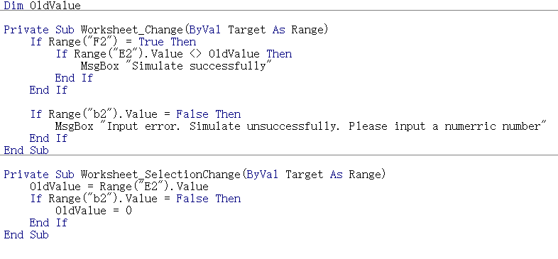

Fig 2 Code for warnings and prompts test simulation

1. Set the value of coefficient with a random numeric number.
2. Choose a numeric value for **input value [U]** and input this value to A2
3. Record the results from B2 and F2. Also record the messages from the message boxes.
4. Choose a non-numeric value for **input value [U]** and input this value to A2
5. Record the results from B2 and F2. Also record the messages from the message boxes.

# Expected result

When a numeric value is input in A2. The values of B2 and F2 are both True and message box should be same as the following picture:

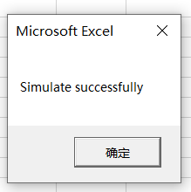

Fig 3 Expect result 1 for warnings and prompts test simulation

When a non-numeric value is input in A2. The values of B2 and F2 are both False and message box should be same as the following picture:

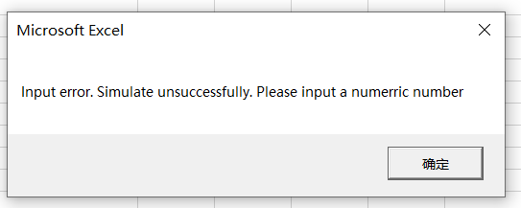

Fig 4 Expect result 2 for warnings and prompts test simulation

# Conclusion

When a numeric value is input in A2, there is no prompts of successful simulation, and when a non-numeric value is input in A2, there is no warning, the test are failed.

Otherwise the tests are successful.